Answer the questions in a separate document. Don’t return the pictures. 2 points each answer 24 points

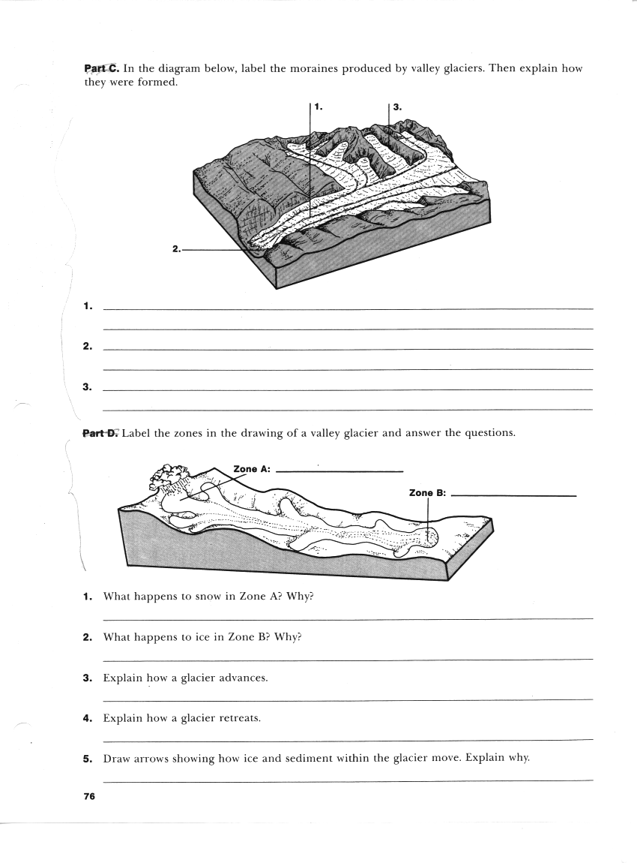
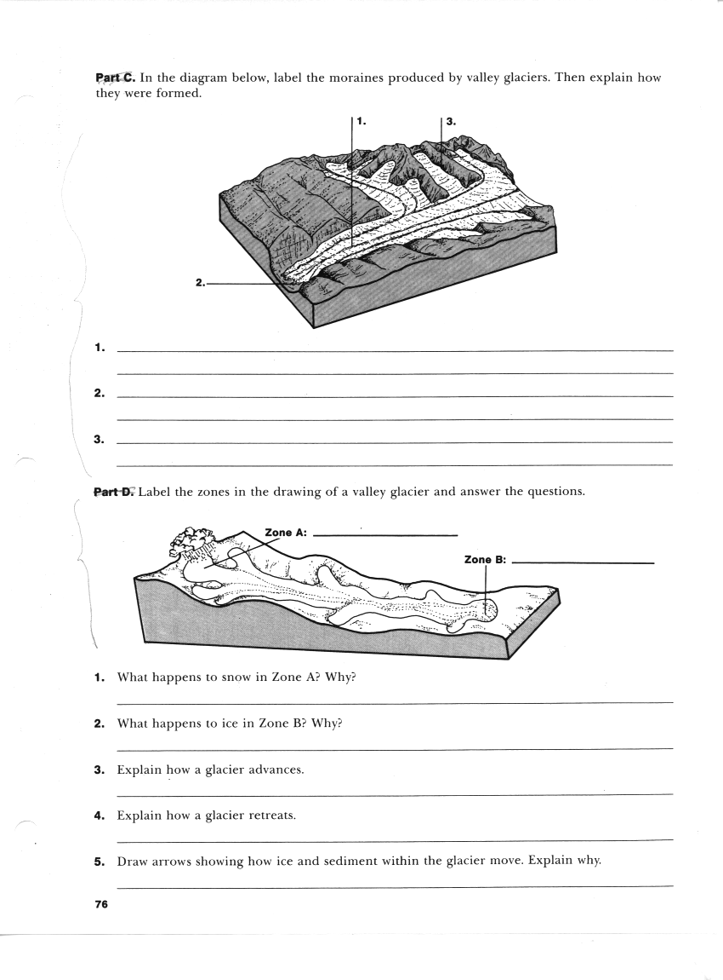

- What happens to snow in Zone A? Why?
- What happens to ice in Zone B? Why?
- Explain how a glacier advances and this doesn’t mean taking giant steps forward. See the explanation for this terminology on p.266-267
- Explain how a glacier retreats and I don’t mean they go backwards. See p.266-267

